Post trip assignment
Name:
Trip date:
60 pts.
Directions: Answer the questions as per the recommended word count. Partial sentences will not be accepted as proper answers. You will lose points for poor writing and grammar. Please put together reasonable arguments or narrative. Upload your answers to ELMS by Wednesday, April 18.
Where we were.
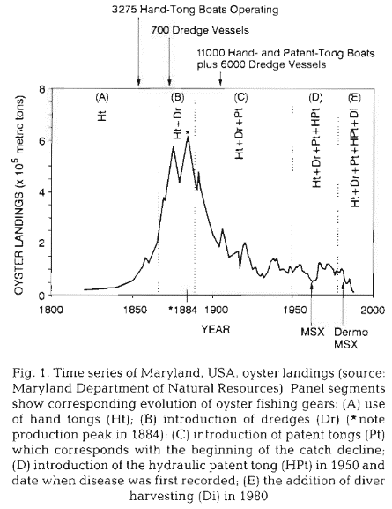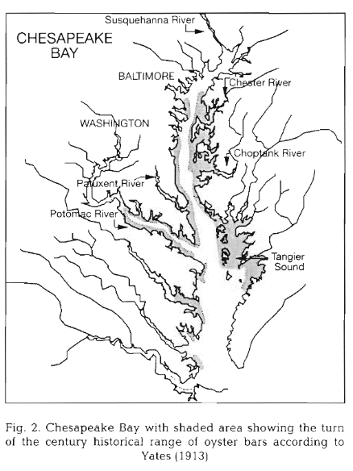

- The boat that we went on was used to harvest oysters. (See the decline of oysters in the figures above.) Describe at least two ways how oysters were harvested. Why does the skipjack have a sail? How is the structure of the skipjack reflective of the culture and (physical nature) of the Chesapeake Bay? (e.g. it has a keel that you can bring up—why?). (15 pts.)
- Of the 2 million eggs that a female blue crab lays, how many survive? (2 pts.)

- Does a sail boat sail directly into the wind? (3 pts.)

- What is the difference between the Chesapeake Bay Foundation, the Chesapeake Bay Program, and the Sea Grant Extension? Are there other programs in the Bay that interest you? How can you be involve in the programs and efforts that are taking place within the Bay watershed? (at least 400 words) (35 pts.)

- Answer two of the following three questions (2 pts each):
  - What is a futtocks?
  - What is the difference between a clam and an oyster
  - What was your favorite part of the trip?
- Should ETE do this trip again? Why or why not? (1 pt.)

