By Chris Mooney June 15, 2016 Link to original Washington post article
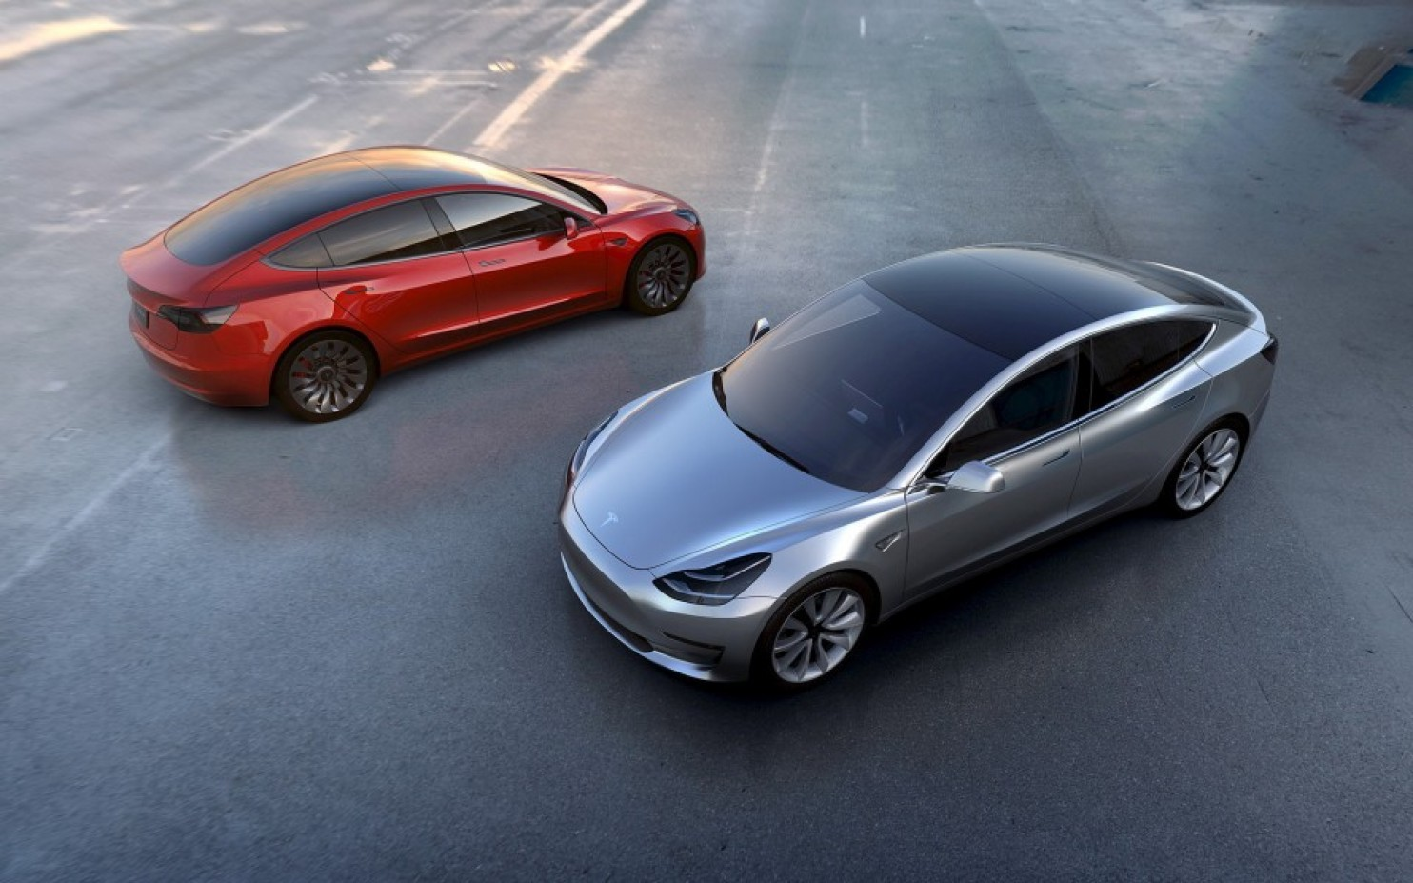
Tesla Motors” Model 3 electric cars. (Tesla Motors via Reuters)
Earlier this year, breathtaking numbers of pre-orders for the Tesla Model 3 not only shocked the auto industry but suggested that a transition of the U.S. and world auto fleet toward electric vehicles could happen faster than expected.
There are still only a little more than 400,000 electric vehicles on the road in the United States, or just 0.16 percent of all cars. But predicted growth rates could have them at more than one-third of new car sales globally by 2040, according to Bloomberg New Energy Finance. And the growth won’t just be in personal vehicles — services such as Uber and Lyft, and makers of self-driving cars such as Google and Tesla, could also drive fast growth of the electric vehicle, or EV, fleet.
As the cars and their batteries get cheaper, meanwhile, they’ll become more and more accessible to buyers — even as a profusion of charging stations to service growing numbers of vehicles will help address the major psychological factor holding people back: “range anxiety.” These trends, combined with climate change concerns, all presage a bright future for the electric car.
All of which means that at some point — and maybe not that far from now, at least in certain neighborhoods or areas — this trend could start to have key implications for the entire electricity system, says a new report released Wednesday from the energy think tank the Rocky Mountain Institute.
An electric vehicle with a 30-kilowatt-hour battery, the report notes, “stores as much electricity as the average U.S. residence consumes in a day.” It adds that if all U.S. light duty cars suddenly became EVs, “they would require about 1,000 [terawatt hours] of additional electricity per year, or an increase of about one-quarter of our current electricity demand.”

Clearly, a lot of EVs means a lot of electricity use. In particular, if large numbers of EVs are charging at roughly the same hour of day — and that time of day is likely to be when people get home from work, which is when electricity use spikes already — the repercussions could be massive. Electricity is most expensive during these peak hours, and power companies have to fire up “peaker plants,” usually driven by natural gas, to slake demand.
“If it increased the peak we would have to invest more money for more generation capacity for the peak, which is the most expensive kind of generation capacity,” says the Rocky Mountain Institute’s Chris Nelder, one of the authors of the report.
This is either a huge coming problem — or a huge opportunity. The Rocky Mountain Institute report sees it as the latter.
The idea is that if we can find ways to shift when this growing fleet of electric vehicles charge up — either toward daylight hours, when they’re more likely to be powered by solar, or to overnight hours, when electricity is cheap — then it opens up a number of options and efficiencies. The result, the report says, could actually be more renewables on the grid, fewer greenhouse gas emissions and cheaper electricity prices.
“Instead of investing in this peak capacity, we want to shift that charging so that it happens in the middle of the night when you’ve got baseload capacity sitting there running,” Nelder says. The result, he says, could “actually optimize the use of all the other assets on the grid. And in so doing, it could actually reduce the per kilowatt-hour cost of electricity.”
That’s one option — which could be accomplished, the report says, by creating financial incentives, in the form of time-varying electricity rates, to push more people to charge overnight, which they’ll be able to do with sophisticated charging controls or apps that give the option of having cars draw power while the owners are asleep.
But another idea is to shift more charging toward the middle of the day — the prime time to take advantage of growing amounts of solar power, especially in key places like California. In this scenario, the growing number of EVs are “basically going to act like a big sponge to soak up all that power,” Nelder says. This would make every mile driven by these EVs greener, and it would also probably flatten the peak of daily energy demand.
The critical factor, though, would be the vast infrastructure of charging stations that will need to accompany EV growth.
“For that load to have a positive, as opposed to negative, effect on the grid, those chargers need to be where vehicles can plug into them at the right time,” the report says.
As the right time is likely to be in the middle of the day, the chargers need to be located at workplaces, malls and other public areas.

It also isn’t clear who will be deploying all these chargers — private charging companies, or large utilities. The latter would presumably have a greater incentive to site them in a way that fits with an overall vision of how the grid will operate.
Nonetheless, strategically timing the charging of EVs opens some interesting possibilities for the grid. For instance, the Rocky Mountain Institute study notes that if “aggregator” companies could simultaneously control the timing of charging for large numbers of EVs (with each owner receiving a small payment for allowing this), they could then effectively switch charging off and on as a form of “demand response” that lessens pressure on the grid at key times, and so further optimizes its performance.
The report does not, however, look very deeply into one other theorized way that fleets of electric vehicles could interact with the grid — by serving as distributed batteries, and temporarily discharging power when needed for various grid services.
“I think in every case, if you plugged in your EV right now, and used it to supply energy back to the grid, it would void the warranty on the vehicle,” Nelder says. He thinks this possibility is just too far off right now, though he acknowledges that that, too, could change.
For now, the primary goal is waking up the electricity sector to a coming EV boom.
“We don’t want utilities and regulators sleeping on this,” Nelder says, “because if they don’t see it coming, and they don’t put appropriate tariffs and regulations into place, if they don’t make sure that they’re helping get charging stations put in place at the right places where people can access them at the right time of day … they’ll lose control of the situation.”
Chris Mooney reports on science and the environment.
Follow @chriscmooney

